HACKATHON

HEWLETT PACKARD ENTERPRISE **– KSHITIJ’18**

**Topic-****Automatically Detect & pinpoint the exact location of Sewage Blockage**

**Team details-**

**Name- Oyster**

**Member 1- Sholi Singh Jindal.**

**Email-id** [**Sholissj@gmail.com**](mailto:Sholissj@gmail.com) **contact number -9454618621**

**College – Meerut Institute of Engineering & Technology,Meerut**

**Idea- Sound travels at different speed in liquid,semi-liquid & gaseous medium. Calculation of time taken for Transmission of sound at high frequency & high amplitude through a sewage pipe can determine how much sewage pipe is filled with actual sewage or there is a blockage(accumulation of large quantity of solid waste, which results in faster transmission).**

The IoT system consists of

1. large number of Sonar Transmitter & Receiver modules(placed on Sewage pipes),
2. a micro-controller
3. server/cloud computer.

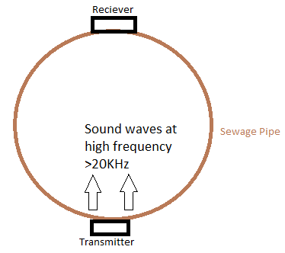

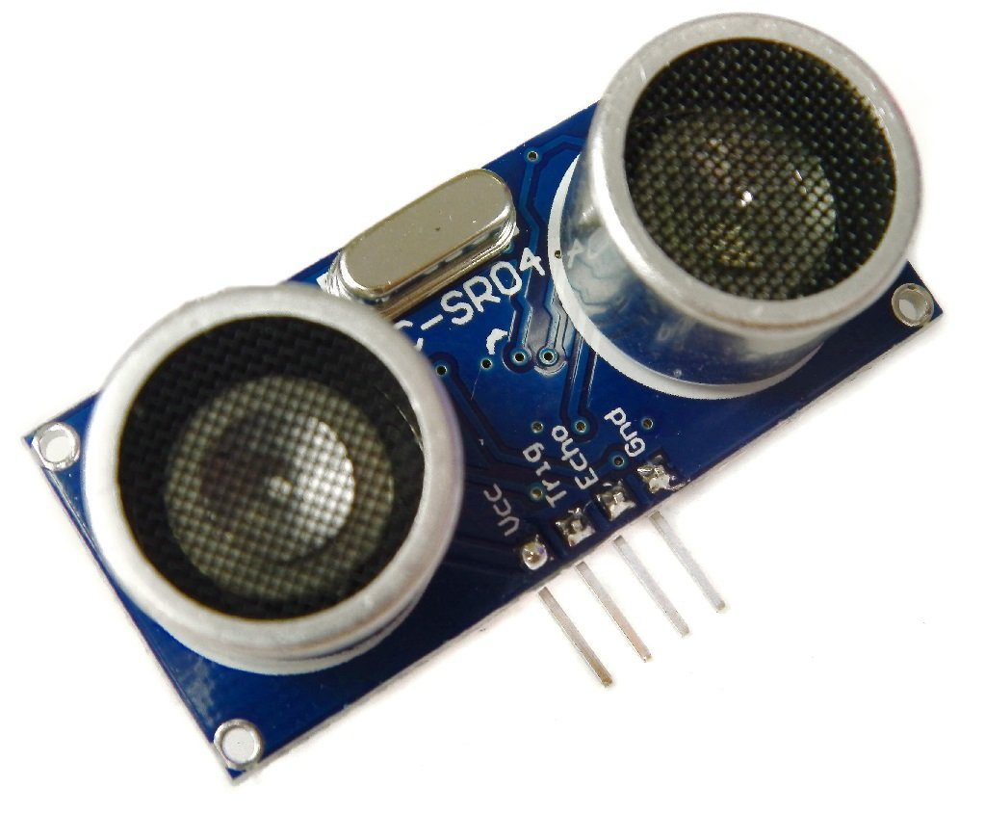

Task of Sonar Transmitter & Receiver- Transmitter transmit sound at high frequency through sewage pipe when signal is sent through micro-controller & Receiver receives the sound at sends signal to micro-controller which contains information of time delay between sound creation & reception. These modules use very low energy & can be powered through small solor panels on road. These sensors are already available in market .

Micro-Controller-It’s task is to regularly scan through all the sensors to check for blockage. Data for normal values will be already saved in program & it will compare the received values from sensor & will alert or send information to hardware/server etc. for notifying the user for blockage.It also use Encoder & Decoder for sending & receiving data.(for example if micro-controller 20 pins spare for sending & receiving values through sensor , it can operate over 210 sensors.)

Server/Cloud- Will act as a center for viewing data, it will receiving data & operating on those data. Some of the task Cloud computer can perform it to predict time - when the sewage will block , or it’s vulnerability( rise of too much solid waste) etc.

Thank you